Going out on the Town
Meteoroids 2013 Participants on a Poznań

Guided Tour, Wednesday 28

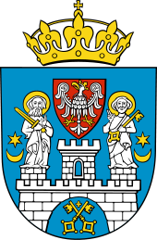
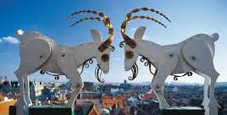

On Wednesday Aug 28th, halfway through the conference, the conference participants took part in a guided tour around Poznań. Judging by the comments and questions heard on the way, the tour was a welcome break from lectures, and hopefully it left some good memories of the city, despite the rain at the end.

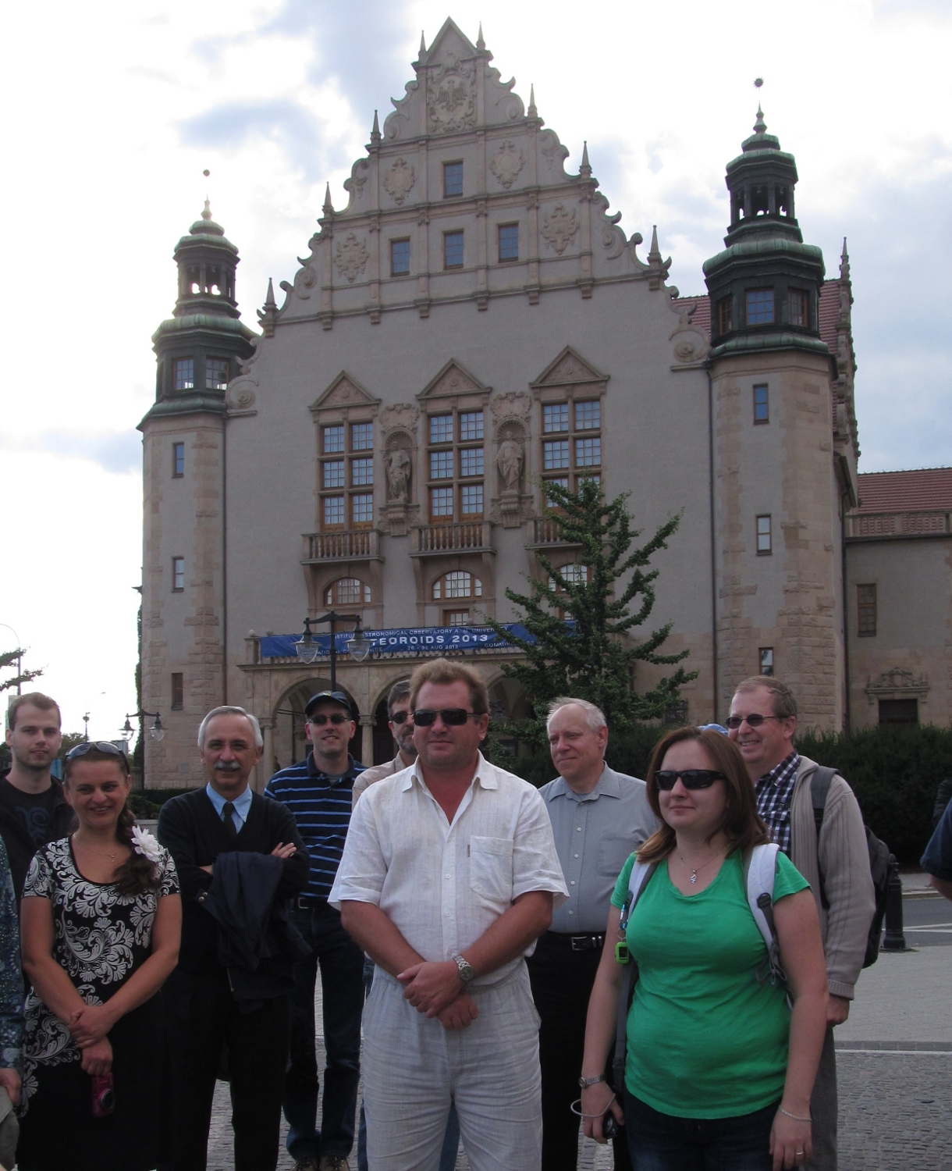

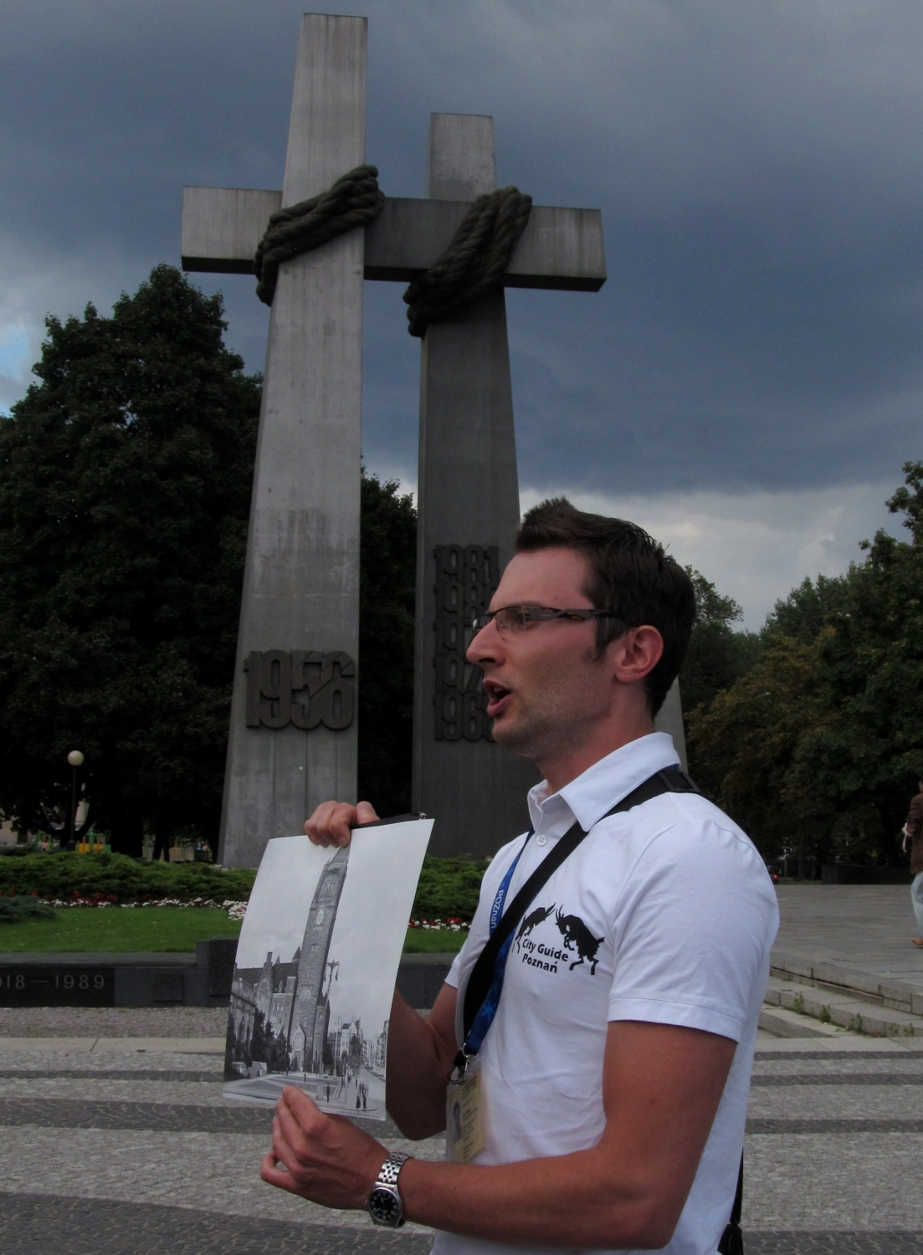

The tour started at the Mickiewicz Square, where the guides gave an overview of what Poznań is all about, explaining for example why the city is associated with billy goats, trade fairs and why Posnanians are Scots*.

The next stops were:

the Grand Theatre,

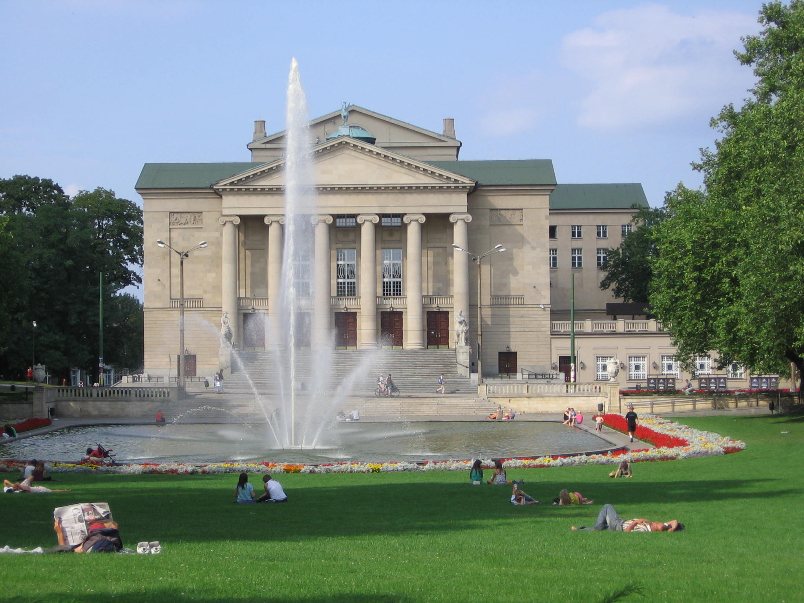

Medical University,
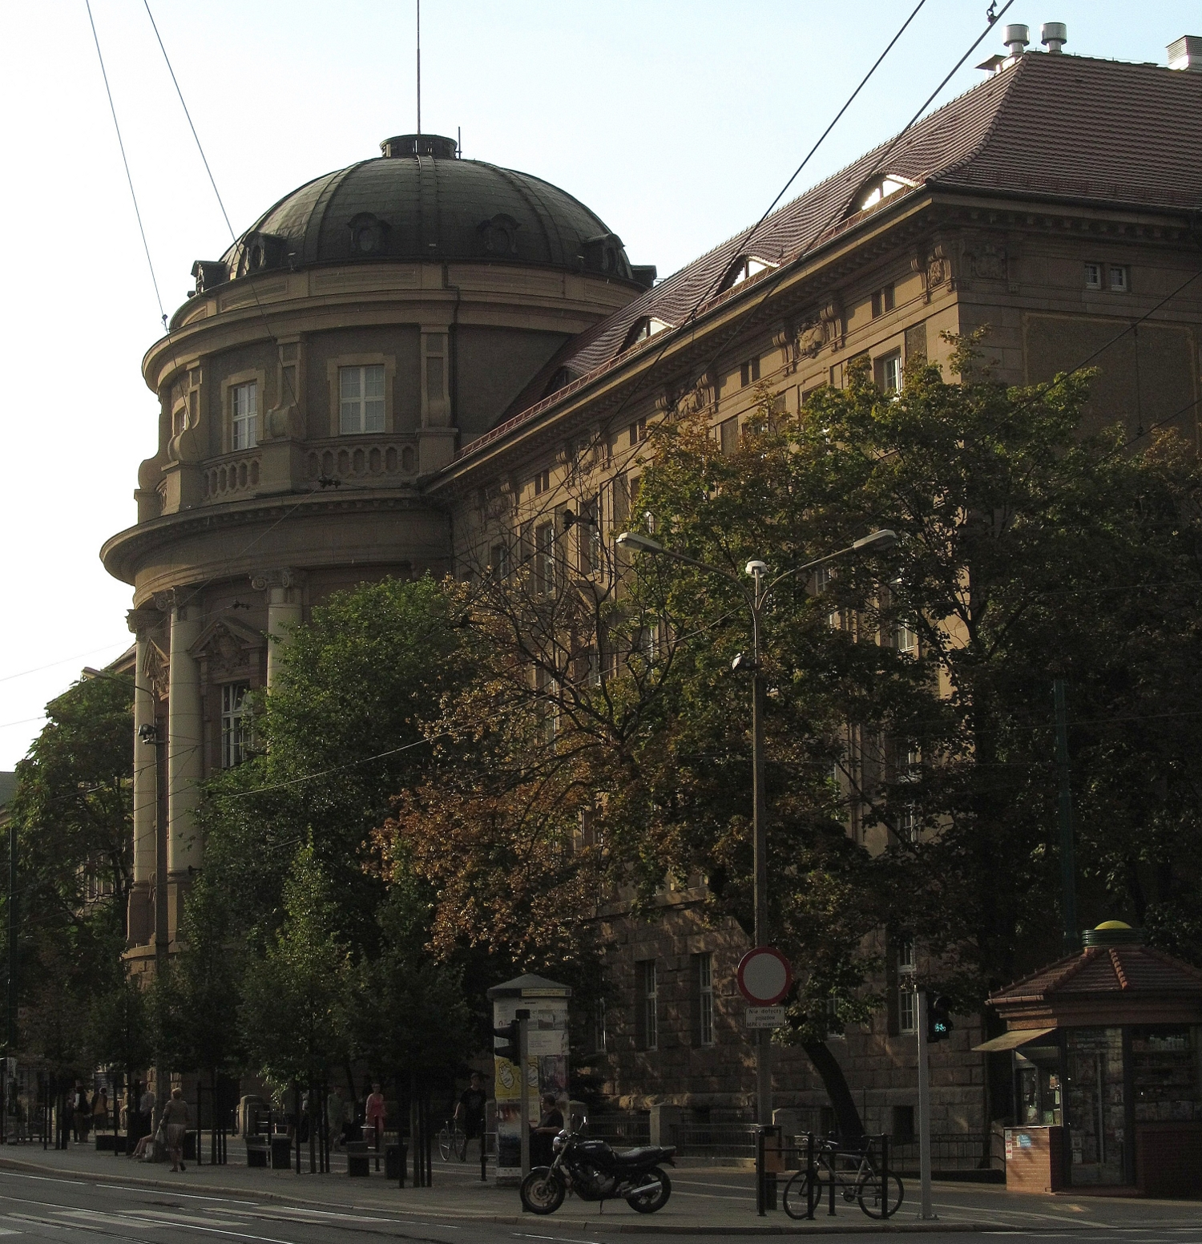

Imperial Castle,

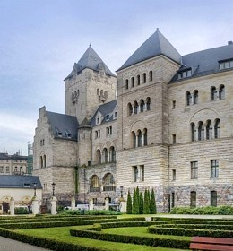

and on towards the Independence and Market Squares.
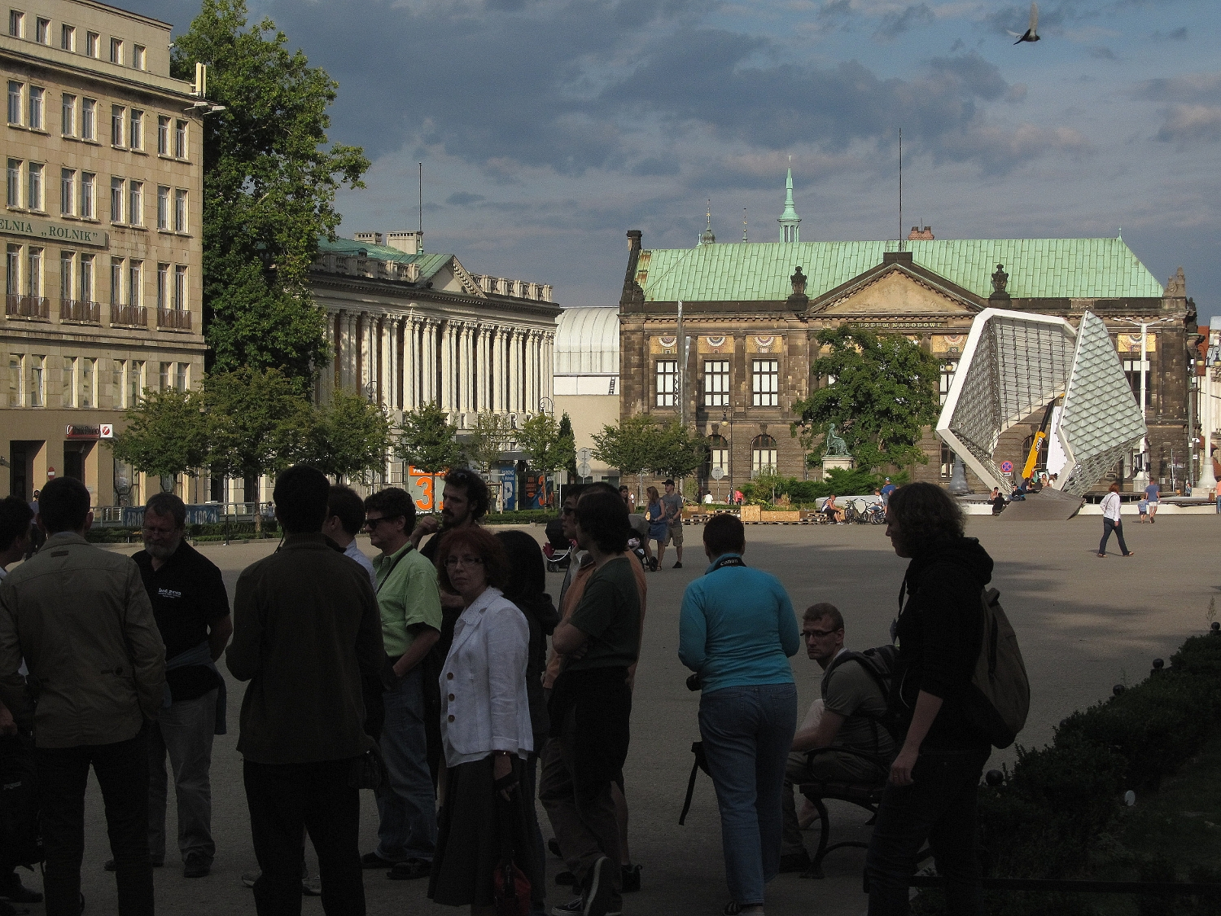

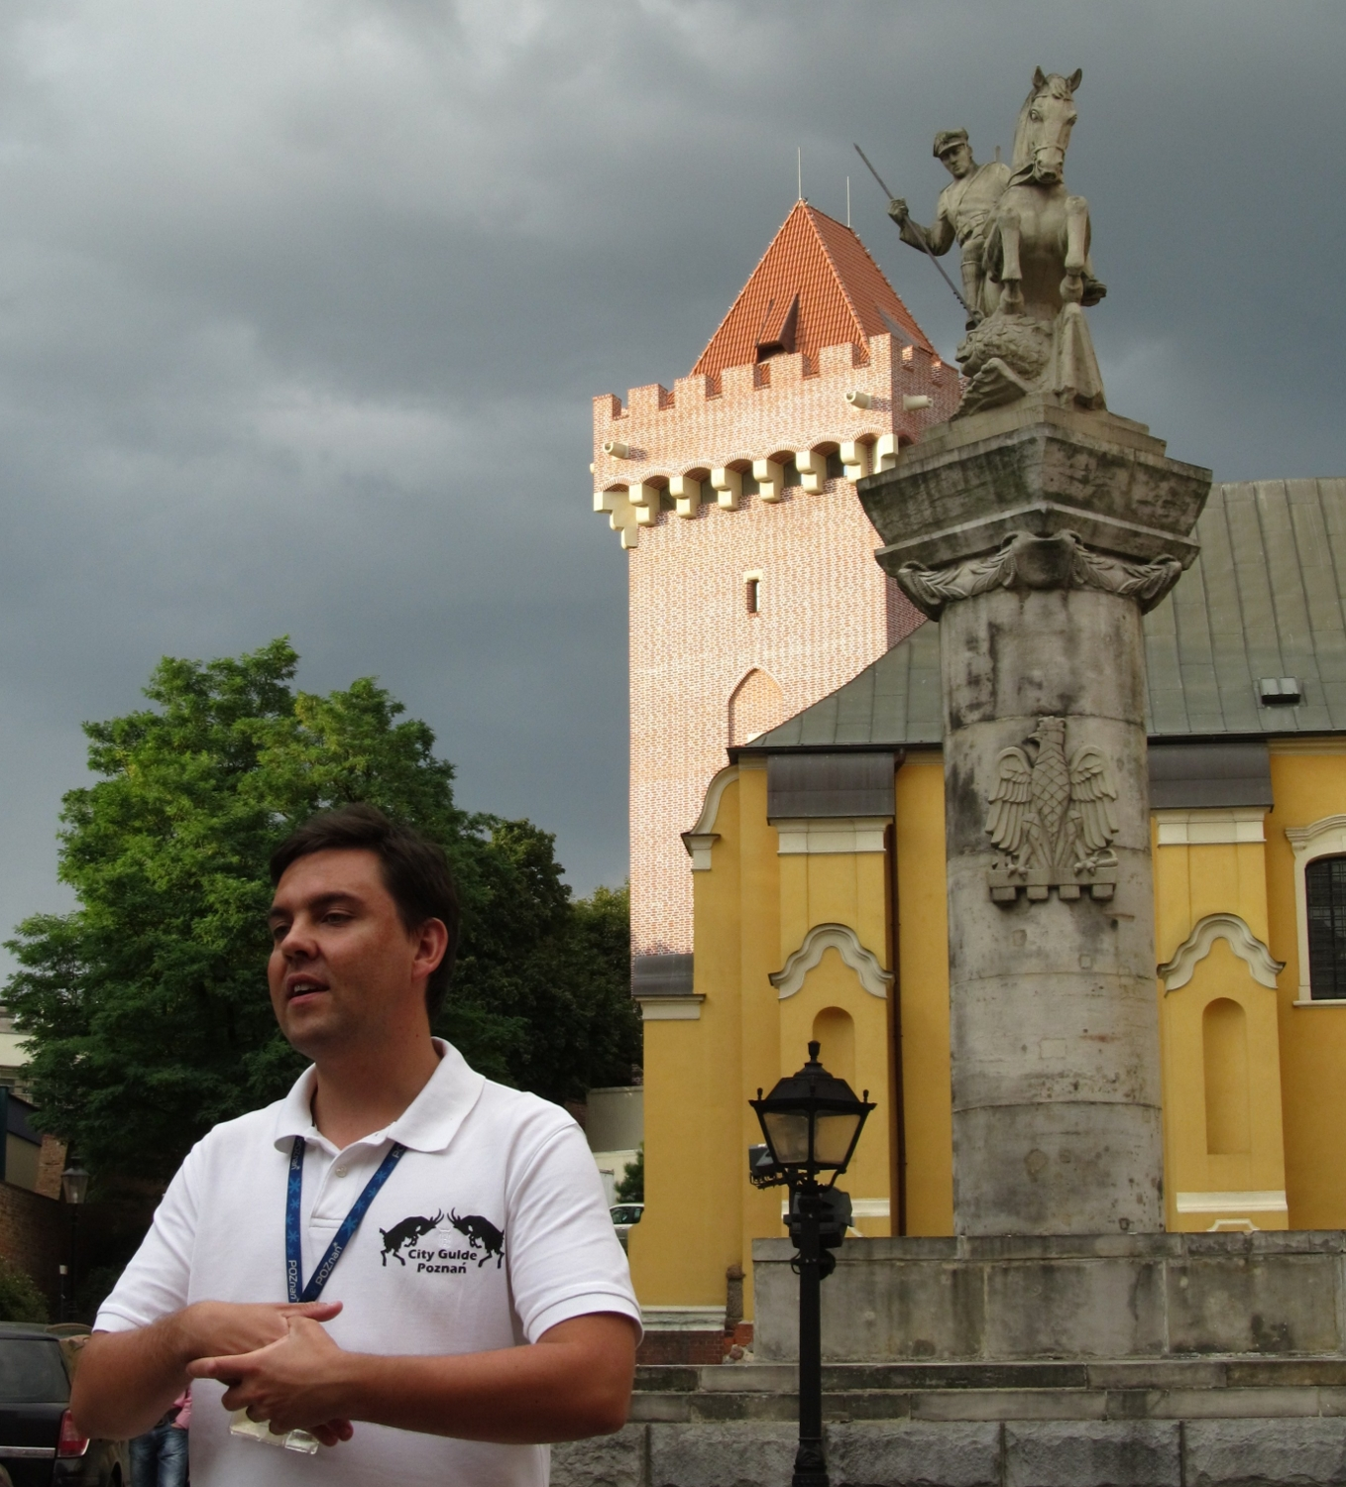

Each of these stops was accompanied with comments, which were a mix of historical facts and city anecdotes that would sometimes bring bursts of laughter among the group.

Here are some interesting questions and comments made by the participants:

“What’s the connection between Poznań and St. George?”

“How much was Poznań destroyed during WW2?”

“What are the main religious groups in Poznań?”

“Are there any buildings in Poznań where Copernicus lived or stayed?”

On the Independence Square:

“People must be very rich in Poznań.
All you can see here are banks and banks …”

Medical University
Piotr (the guide): “Karol Marcinkowski would prescribe beer for cholera”
Someone in the group: “Of course, it has always been the best medicine”

Posnanians

*A common joke (truth?:) has it that Posnanians are in fact Scots that were expelled from Scotland for being too tight-fisted.

Photos and the text courtesy of City Guide Poznań

