State Committee for Scientific Research – KBN For KBN use only
00-529 Warszawa Nr.
ul. Wspólna 1/3 Group
POLAND
GRANT APPLICATION

Project Title:
Observation and analysis of eclipsing binary stars, determination of distance employing photometric parallax.

A. APPLICANT DATA

- Name and address of the organization where work will be performed (include department, institute, laboratory, and chair, as applicable):
Adam Mickiewicz University
Wydział Fizyki
Astronomical Observatory
Ul. Słoneczna 36, 60-286 Poznań

2. Principal Investigator (include title, first name, last name):
MSc Wojciech Dimitrow

3. Principal Investigator’s employer, if different from above organization (include department, institute, laboratory, and chair, as applicable):

B. GENERAL DATA

1. Funding period: 12 months

2. Number of personnel involved in the project: 1

3. Type of project (pick one): Individual Project – Doctoral Dissertation Grant – Solicited Project

4. Requested funding amount (in Polish zlotys - zł): 19 730zł

5. Keywords: eclipsing binary stars, photometric and spectroscopic observations, model, photometric parallax

6. Project summary (not to exceed 1 page; may be published by KBN if grant is awarded):

I propose to perform spectroscopic observations of detached binary stars, to be analyzed in conjunction with photometry for obtaining accurate models of the stars by means of Wilson-Devinniey analysis, and eventually absolute magnitudes and photometric parallaxes. This is of course not the final aim, because there are many binary systems with well determined distances. We propose to analyse bright stars with trigonometric parallaxes obtained by Hipparchos. Thus analysis of any systematic differences might contribute to verification of the photometric parallax zero point, depending primarily on the calibration of surface brightnes-color relation. Interest in recalibration of the binary photometric parallaxes stems from projects applying them as galactic and extragalactic cosmological standard candles. These projects employ large telescopes and Hipparchos stars are to bright for them. At the same time, where appropriate, our data enable useful verification of evolutionary track isochrones by their differential comparison with components of a binary, in a way free of distance and zero-point calibrations.

C. STAFF INFORMATION

For the Principal Investigator and each senior staff member, provide the following biographical information:

1. Name: Wojciech Dimitrow

2. Educational history including, for each degree, the field, institution, and date obtained

MSc: Adam Mickiewicz University
3. Academic and professional appointments, in reverse chronological order
“Occultation of stars by the Moon” (MSc thesis)
4. Brief descriptions of research projects completed in the last four years, including up to 10 publications (provide publication data).
published paper: “IO Aqr: the twins just at turn off”, Astronomy & Astrophysics,
(A&A 417, 689-693, 2004)
5. Awards received

D. PROJECT DESCRIPTION, METHODOLOGY, AND EXPECTED RESULTS

Motivation: Because of their model inherent simplicity, detached eclipsing binaries constitute potential accurate distance indicators by means of their photometric parallaxes (Paczynski, 2001). As such they are being currently employed by several galactic and extragalactic surveys on large telescopes. However, their usefulness at desired accuracy levels of order 1-2% is restricted by poor zero-point calibration, tied to the surface brightness/temperature relation. As pointed by Kruszewski & Semeniuk (1999) this could be remedied by re-observation of bright eclipsing binaries with parallaxes measured by Hipparchos. The aim of the present limited scale project is to contribute data for several objects of this type. I propose observation and analysis of a selected group of eclipsing binary stars, basing on (literature) photometric and (own) spectroscopic observations. The fitted Wilson-Devinniey (1971) models will be used to calculate the photometric parallax and also to verify them against Hipparchos parallaxes. For this purpose we employ relatively bright eclipsing detached binary systems observed by Hipparchos and lacking binary solutions. Note that here we are concerned mostly with the detached subgroup of Algol systems, as opposed to the semi-detached ones.

Methods: We employ photometry mostly from ASAS (All Sky Automated Survey, Pojmański 1997). Pilot spectral observations carried out on 2m telescopes at NAO Rozhen (Bulgaria) and David Dunlop Observatory (Canada) will be demonstrated below. We propose to continue these observations. Our spectra obtained in three spectral regions NaD, Hα and Calcium triplet were processed with the standard IRAF procedures. We have used cross correlation to determine radial velocities. The obtained radial velocities and light curves are fed to Wilson-Devinney (1971) code, as modified by Plewa (1992, 1988). The principle may be explained by the following simplification, assuming inclination 90°, circular orbits and spherical stars. Radial velocity curves contain information about the orbital velocity of both components. Using the third keplerian law and motion around the barycenter (two constraints) we can calculate mass of both stars. Photometry gives us information about the beginning and the end of eclipse. In the simplified case the time interval between the first and last contacts corresponds to the relative shift of the components by 2R1 + 2R2. Duration of the flat bottom of eclipse yields the same for |2R1 - 2R2|. Using this two conditions, moments of and velocity of stars we can determine the radii of both stars.

The real life is more complicated: inclination i and mass-ratio q are a-priori unknown, eclipses can be partial and the stars are tidally distorted. Simultaneous use of both light- and radial velocity-curves makes the (i,q) indeterminacy less acute. By experiments we found that presence of some ellipsoidal variation helps to make the solutions better constrained by imposing strict condition on the tidal distortion. The solutions are handled by Wilson-Devinney code, taking into account orbital inclination, tidal distortion of stars, limb darkening, gravity darkening, and reflection effect. The input temperature of the stars we take from spectral type or color index and stellar atmospheres models, using information contain in two-color light curve. Multicolor photometry is useful to further limit the values of temperatures of components. We obtain additional CCD differential photometry on 0.4m telescope at Borowiec Observatory.
Feasibility: Figure 1. demonstrate results obtained for IO Aqr (published A&A, 2004). Inspection of Fig. 1 reveals good quality of our spectroscopy, yielding masses with 2% accuracy. Agreement of the model and observed light corves is excellent. Our photometric parallax differs from that of Hipparchos by 20%.
Prospects: Basing on absolute and visual luminosity of the star we can determine the distance and also evolutionary status of the components. To verify the method we can compare our result with trigonometric parallax given by Hipparcos. The results of the project will be published and used in my PhD thesis.

References

Kruszewski, A., Semeniuk, I., 1999, I., Acta Astronomica, 49, 561

Paczyński, B., 2001, Acta Astronomica, 51, 81
Plewa, T., 1988, Acta Astronomica, 42, 103
Plewa, T., 1992, Acta Astronomica, 38, 415
Pojmański, G., 1997, Acta Astronomica, 47, 467
Wilson, R.E., Devinney, E.J., 1971, ApJ, 166, 605

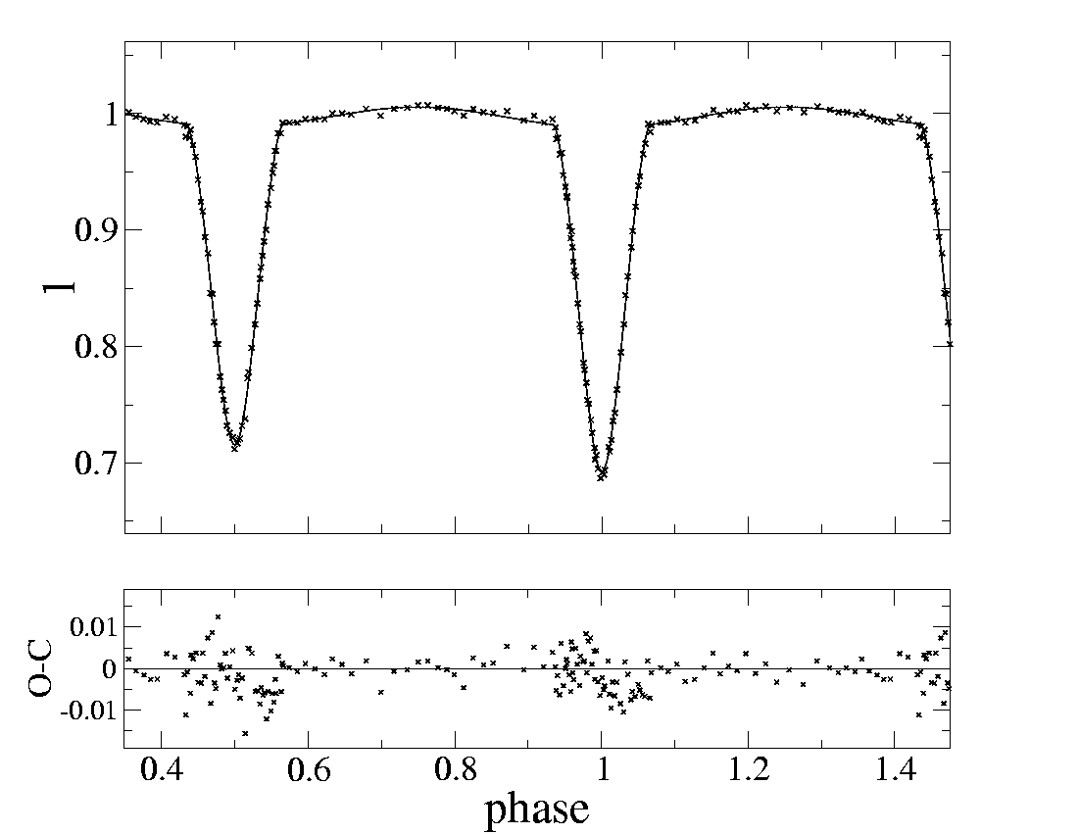
Fig 1. Synthetic light and velosity curve for IO Aqr 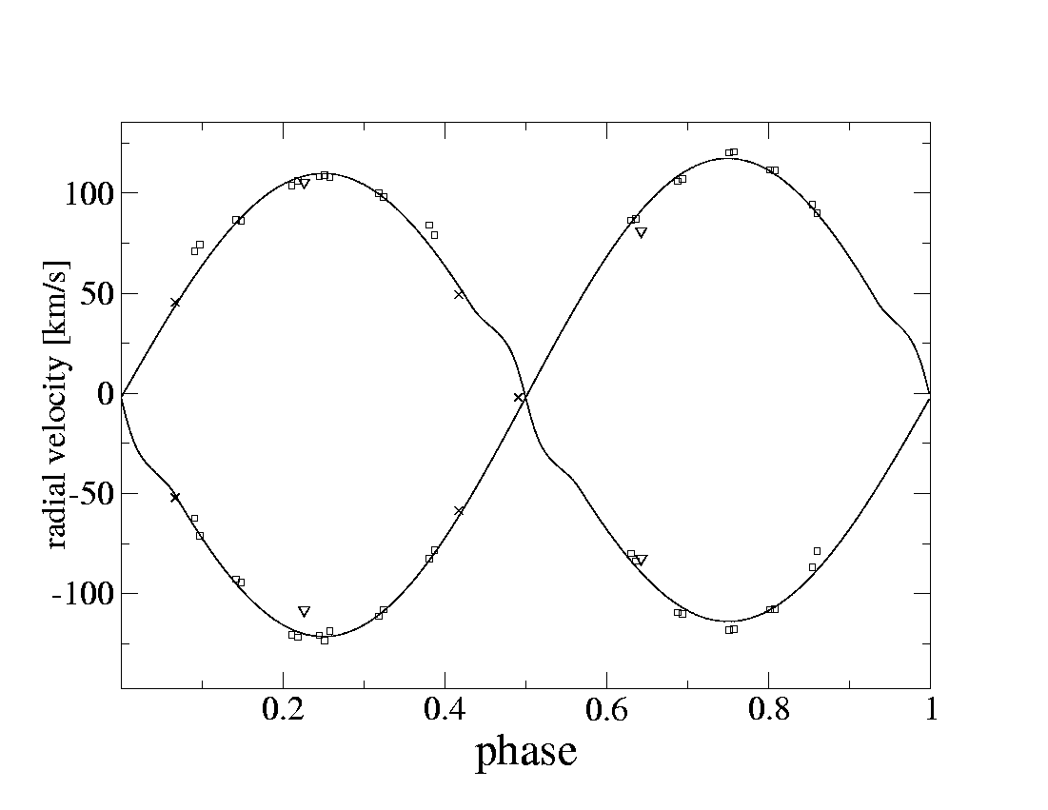
E. SOLICITED PROJECTS ONLY: DOES THE APPLICANT MEET THE CALL CRITERIA, PARTICULARLY THOSE CONCERNING INTERNATIONAL COOPERATION?

F. PROJECT SCHEDULE - ANTICIPATED TASKS

No. | Name and description of task | Expected completion date  (mm/yy) | Expected cost  (zł)
 | Equipment | 31.12.2005 | 4000
 | Observations and analysis | 31.6.2006 | 15730
 |  | Total | 19730

G. PROPOSED BUDGET

No. | Item | Funds for each budget year (zł)
 |  |  | 2005 | 2006 |  | Total
1 | Direct costs, including: |  | 4000 | 12100 |  | 16100
 | 1/ Salaries and benefits |  |  | 6000 |  | 6000
 | 2/ Equipment |  | 4000 |  |  | 4000
 | 3/ Other direct costs |  |  | 6100 |  | 6100
2 | Indirect costs |  |  | 3630 |  | 3630
3 | Total costs (1+2) |  | 4000 | 15730 |  | 19730

Details of direct cost items
1) Salaries and benefits
Principal Investigator person-months: 12 months, 6000zł
Staff person-months

2) Equipment (type, estimated cost, planned month of purchase, and justification)
computer and monitor, expected cost 4000zł, expected completion XII.2005

Equipment is indispensable for analysis

3) Other direct costs (type of expenditure, amount, and relation to project plan)
David Dunlop Observatory, University of Toronto, Canada
Spectroscopic observations, expected costs 5500zł

other costs: bank, CDs... 600zł

Date Grantee organization Principal Investigator
14.I.2005 Signature Signature

Polish zloty annual 2003 mid - rate against the euro is estimated at 4.30 (Ministry of Finance - draft budget for the Year 2002)

